**Ocean Thermal Energy Conversion – Flexible Enabling Technology for Variable Renewable Energy Integration in the Caribbean**

R. J. Brecha1,2,3,4, Katherine Schoenenberger4, Masaō Ashtine5, Randy Koon Koon6,

1Climate Analytics, Ritterstr. 3, 10969 Berlin, Germany

2Physics Dept., University of Dayton, Dayton, OH, USA 45469

3Renewable and Clean Energy Program, University of Dayton, Dayton, OH, USA 45469

4Hanley Sustainability Institute, University of Dayton, Dayton, OH, USA 45469

5Department of Engineering, University of Oxford, United Kingdom.

6Department of Physics, University of the West Indies, Mona Campus, Jamaica, W.I.

**\*Corresponding author**: R.J.B robert.brecha@climateanalytics.org

**Keywords:** Ocean thermal energy conversion, OTEC, seawater air conditioning, SWAC, desalination, variable renewable energy, wind power, solar PV, 100% renewable energy, Caribbean

**Abstract**

Most Caribbean island nations have historically been heavily dependent on imported fossil fuels for both power and transportation systems. At the same time, small island developing states (SIDS) are at enhanced risk from the impacts of climate change, although their own emissions represent only a very tiny fraction of the global total responsible for climate change. For this latter reason in particular, SIDS have been leaders in advocating for the ambitious 1.5°C Paris Agreement target. Because of the increasing recognition that domestic renewable energy resources would be adequate to supply energy needs, Caribbean islands have the potential to lead as well in demonstrating the ability to transition to 100% sustainable, renewable energy systems. In this work we present three central results in this space. First, we show through GIS mapping of all islands the potential for near-coastal deepwater as a resource for Ocean Thermal Energy Conversion (OTEC) and couple these results with an estimate of which countries might best take advantage of this resource due to lack of other dispatchable renewable power options. Second, we use hourly data to show explicitly the trade-offs between battery storage needs and dispatchable renewable sources. Finally, we analyze tradeoffs and estimated total system levelized costs for combinations of variable renewables, dispatchable renewable power and storage to achieve 100% renewable electricity generation. In particular, this last point is emphasized to demonstrate the utility of open-cycle OTEC together with accompanying desalination in enabling a high penetration of renewable energy and a system cost, even including the relatively expensive OTEC technology, that is lower than costs of a fossil-fuel-based system.

1. **Introduction**

Ocean energy technologies can help play a role in enabling island states to reach targets of energy self-sufficiency (IRENA (International Renewable Energy Agency), 2014; Lewis et al., 2011) Three basic, but linked ideas are behind the continued interest in Ocean Thermal Energy Conversion (OTEC) in particular (Lennard, 1995; Vega, 1992; Watt, Mathews, & Hathaway, 1977) . First, as shares of increasingly economical variable renewable energy (VRE) sources such as wind and solar photovoltaics are incorporated into the energy mix, there will still be a need for dispatchable electricity sources to complement variability ( Suberu, et al., 2014) . Second, much as with sun and wind, ocean energy as a primary resource is essentially infinite and not depletable. Third, OTEC can also provide extra services beyond the generation of electricity.

In spite of these important driving factors and some continued interest in OTEC by research groups and commercial ventures around the world, uptake has thus far been slow. Predictably, one of the valid reasons for lack of adoption has been the relatively high up-front cost that is expected for any emerging technology. In general, technologies follow an experience learning curve, described by decreasing costs per installed unit or per unit of generated electricity, expressed as a function of total cumulative installed capacity (Arrow, 1962; Grübler, et al.s, 1999; Nemet, 2006). Solar photovoltaics represent a classic example with installation costs dropping by about 25% for each doubling of installed capacity, following this trend for the past four decades (Creutzig et al., 2017). Technology such as OTEC, still in a demonstration phase, will necessarily be comparatively costly.

Another factor that can also lead to hesitation on the part of developers of potential OTEC projects is the relatively limited geographical area over which OTEC can be a viable technology (Lennard, 1995; G. C. Nihous, 2007; Vega, 2010). In fact, compared to wind and solar energy, it is likely that the decreases in cost for OTEC projects may not show dramatic declines beyond those seen in moving from experimental projects to more standardized technology implementation. For OTEC and accompanying desalination and perhaps Sea Water Air Conditioning (SWAC) to be implemented, developers require (a) a viable coastline resource (including the absence of Marine Protected Areas or sensitive wetlands, for example), (b) bathymetry that allows for relatively deep ocean waters (~1000m or more) within close proximity (~5 km or less), and finally, (c) towns or fairly urbanized developments with electricity transmission infrastructure near these coastal areas.

While not likely to become a worldwide mass-market technology, we show that OTEC and desalination can play a limited but important role in complementing variable renewables in certain cases. Therefore, bathymetric data for nearly all islands in the Caribbean has been examined to determine which are the most likely candidates using the three proximity criteria above, together with a fourth criterion that sufficient, less expensive or more developed dispatchable renewable resources (e.g. hydropower or geothermal) are not readily available. Most crucially, this research shows at least two reasons that OTEC should not be judged as a technology in isolation, for example in terms of the levelized cost of electricity (LCOE) generated. The first argument for OTEC is focussed on applications where the power systems are heavily dependent on variable renewables, as such the value of a dispatchable source goes beyond the actual electrical energy generated, but in the ancillary services that can be provided to the system in terms of stability. While batteries are increasingly an economically viable option for backup, a balance between storage and dispatchable power will be necessary, with consideration of the overall system-wide LCOE, not that of each technology individually, being a more prudent way to view planning toward a 100% renewable energy future. This is especially true in the context of small island developing states (SIDS) in the Caribbean, many of which are just beginning transitions from a nearly complete reliance on oil for power generation, and thus have the opportunity for taking a longer-term systemic view of power system transformation.

The second strand of the economic argument is that the combination of OTEC with auxiliary desalination) as a combined system provides multiple services; another potential benefit is the further combination of OTEC and desalination with SWAC as an additional output that is of great value-added on many islands which continue to face increasing pressures owing to climate change.

The following sections present a brief overview of the energy landscape in the Caribbean region, linking resource and economic factors (Section 2). OTEC as a specific technology (Section 3) is presented in terms of both physical and economic factors, and including considerations of desalination and sea-water air conditioning as by-products. These considerations lead to the filtering criteria that are used in Section 4 for a preliminary selection of potential Caribbean sites for OTEC based on GIS mapping of bathymetry, and in Section 5 some economic parameters related to OTEC are presented. In Section. 6 the representative hourly demand, wind and solar data to gain an understanding of the challenges of integrating high levels of variable renewable sources into the power system, leading therefore to the necessity of complementary technologies such as OTEC; the analysis tool of Residual Load Duration Curves (RLDCs) are also introduced. Section 7 is a discussion of the results and provides an outlook for the adoption of OTEC.

1. **Caribbean Renewable Energy Landscape**

In moving toward fully renewable energy systems (and not only power generation, which will be the focus here) there are a limited number of technologies and options available. Wind and solar photovoltaics are the two most plentiful and inexhaustible forms of renewables in the Caribbean and have now become cost-competitive when compared to conventional energy generation technologies (Lazard, 2019a). The integration of renewables across multiple Caribbean nations has been making progress in the region through installations and policy-based initiatives. Increased use of renewable energy has multiple benefits including economic savings (a reduction of fossil-fuel based import in most Caribbean nations), energy production diversification that can aid energy security and system resilience goals, and environmental targets as represented by a reduced carbon dioxide emissions footprint.

**2.1 Status of renewables across the Caribbean**

The abundance of unexploited renewable resources across the Caribbean distinctively positions the region to become a leader in to sustainable development. An overview of the RE potential across CARICOM member states can be seen in Figure 1. Small Island Developing States (SIDS) are acutely focussed on climate adaptation measures through ambitious renewable energy integration plans. With the primary focus being on increasing penetration rates of solar photovoltaics and wind energy across many SIDS, the possibility of reaching 100% RE integration can also be strongly supported through the controlled implementation of Battery Energy Storage System (BESS) (Chen, et al. , 2020). Whereas worldwide hydropower has long been the dominant renewable electricity source, with few exceptions (*e.g.* Jamaica and Belize) hydropower, plays a fairly insignificant role in the region. As shown in the summary in Table 1 as well as in Fig. 1, there are countries that have hydropower resources that may be either very small (Grenada) or already at maximum capacity (Dominica and St. Vincent and the Grenadines).

Another potential energy source, biomass use for power generation largely can come in two forms, either using waste from crops, such as sugar cane, or from purpose-grown bioenergy crops. Biomass electricity can therefore play a niche role in some countries, but especially on some of the smaller islands, a large biomass to electricity capacity is not to be expected due to environmental concerns and climatic conditions.

From Fig. 1, the Caribbean Community (CARICOM) subset of Eastern Caribbean islands from St. Kitts & Nevis to Grenada collectively account for a potential of 6280 MW of exploitable geothermal power (Ochs, 2015)Interestingly, and although not currently planned, a collective approach to exploit this resource could further increase the efficacy of this resource, for example, between the islands of St. Kitts and Nevis(approximately 3.5 km from coast to coast), and between Dominica, Guadeloupe and Martinique through inter-island grid connectivity. (Koon Koon, et al., 2020) On the other hand, geothermal resources whereas the latter technology haves been widely explored but often run into implementation difficulties and delays (e.g. Grenada, St Lucia).

Fig. 1 acts as a template for the selection of potential OTEC nations. The energy statistical data is then perturbed for different potential scenarios of renewable penetration rates. This builds upon the 2027 energy capacity projections outlined by the Caribbean Sustainable Energy Roadmap and Strategy (Ochs, 2015). The following analysis is a two-front approach, comprising both an economical and an environmental aspect. Caribbean member states are vulnerable to the volatile nature of the oil & gas industry, hence a continued interest in fossil fuel importations certainly hinders energy diversification and economic security. Collectively an average price of the domestic retail rate of electricity across CARICOM member states is positioned at USD 0.35/kWh. Therefore, there is a continued need for RE integration to mitigate the fossil fuel importation components. A detailed illustration of the price of electricity for the selected member states when compared to the estimated installed power capacity from fossil fuel imports in 2027 and the Notre Dame Global Adaptation Initiative (ND-GAIN) Index[1] is seen in Fig. 2. The ND-GAIN is an index rating out of 100 (the higher the better) that consists of a country’s vulnerability to climate change and its readiness to improve its resilience. Both the economic (price of electricity) and climate (ND-GAIN) aspects of the selected nations are represented in Fig. 2.

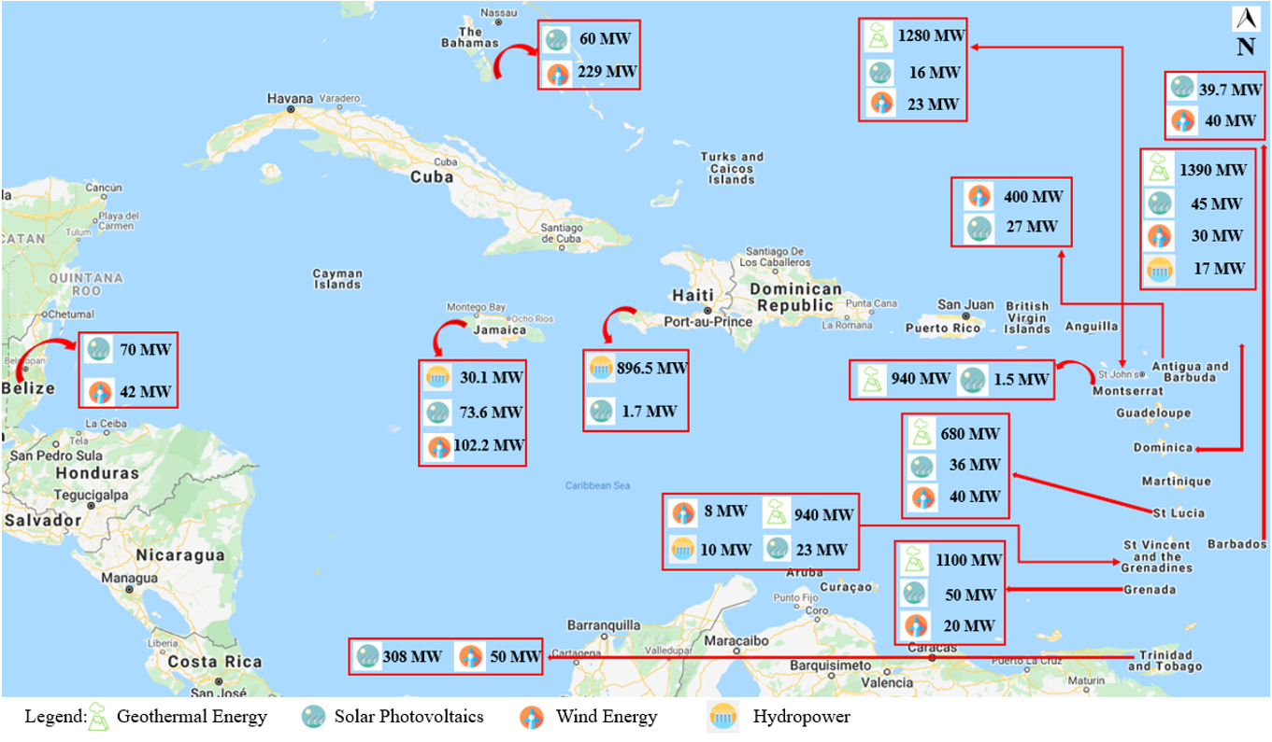

Figure 1 - Renewable energy distribution across the Caribbean nations (Source: Ochs, 2015).

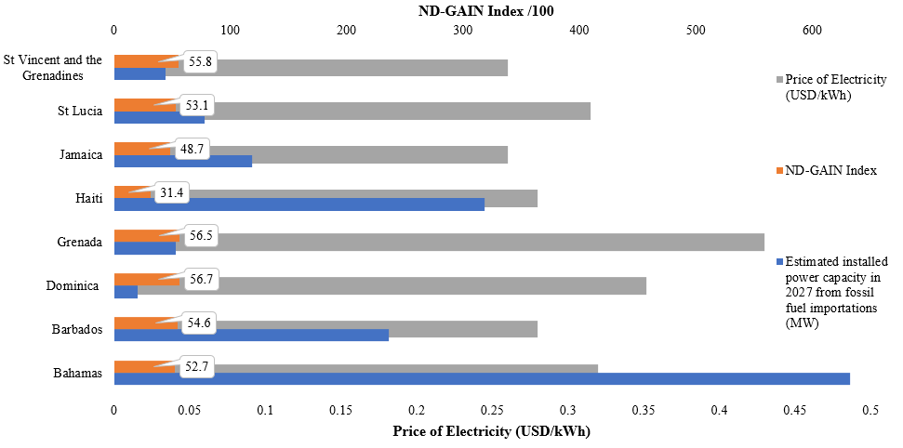

Figure 2 - Economic and climate comparison of selected OTEC nations.

**2.2 OTEC - Dispatchable renewable technologies**

The variable nature of wind and solar power mandates that there be an additional source of energy or storage of energy to complement these two resources. Battery storage is an increasingly integrated option for storing energy whereby utilities operate load shifting methods to ‘transfer’ energy from times of plentiful sun and wind to those times without (Chen, et al., 2020) In a very few cases in the region, pumped hydropower storage, and the increasingly viable conversion of renewable electricity to hydrogen through hydrolysis are also being explored. Hydrogène de France (HDF) for instance has recently invested in developing a 55 MW/140 MWh hydrogen-based solar-plus-storage plant in French Guiana in 2018 with work expected to begin in 2020 (). The other available avenue to complement variable renewable power generation is through the use of a dispatchable (controllable) source of power. If fossil fuel sources and nuclear energy are not considered, a limited number of technologies are available, for example hydropower, geothermal, biomass, waste, tidal, wave, and ocean thermal energy conversion.

The International Renewable Energy Agency (IRENA) surveyed ocean energy resources around the world (IRENA (International Renewable Energy Agency), 2014) For the Caribbean region, both tidal and wave power are poor resources due to limited tidal channels to harness energy and therefore will not be considered within our study. With respect to waste-to-energy, although countries in the region do have waste disposal challenges, the overall amount of waste generation is ~1 kg/person/day) (Tello Espinoza, et al. , 2010) with estimates of the combustion value and the resulting electricity generation from municipal solid waste (Arena, et al. , 2015) leading to an energy production of approximately 90 kWh/capita/year; a relatively small contribution compared to typical island electricity consumption of ~2000 kWh/capita/year. Table 1 gives a summary of potential resources for hydropower, geothermal and OTEC, summarizing the discussion above and with the latter based on the results to be shown in Section 4; here we use the comparison to motivate the results of this paper and look in more detail at Ocean Thermal Energy Conversion (OTEC) as a potentially viable and alternative complementary power source for high VRE penetration, and as a technology that can also provide other co-benefits for those regions in which it is viable

Table 1 - List of Caribbean countries with yes or no filter for potential hydropower, geothermal and OTEC technologies as dispatchable renewable energy

|  |  |  |  |
| --- | --- | --- | --- |
| Country | Hydropower | Geothermal | OTEC |
| Bahamas | n | n | y |
| Cuba | y | n | y |
| Turks and Caicos | n | n | n |
| Jamaica | y | n | y |
| Haiti | y | n | y |
| Dominican Republic | y | n | y |
| Puerto Rico | y | n | y |
| British Virgin Islands | n | n | n |
| US Virgin Isl - St Thomas | n | n | n |
| US Virgin Isl - St Croix | n | n | y |
| US Virgin Isl - St John | n | n | n |
| Anguilla | n | n | n |
| St Kitts and Nevis | n | y | n |
| Antigua and Barbuda | n | n | n |
| Montserrat | n | y | n |
| Guadeloupe | y | y | y |
| Dominica | y | y | y |
| Martinique | n | y | y |
| St Lucia | n | y | y |
| St Vincent and the Grenadines | y | y | y |
| Barbados | n | n | y |
| Grenada | y | y | y |
| Trinidad and Tobago | n | n | n |
| Bonaire | n | n | y |
| Curaçao | n | n | y |
| Aruba | n | n | n |

1. OTEC, SWAC and desalination

The concept of OTEC has been around for over a century, with prototype plants built during the 20th century using both open-cycle (OC-OTEC) and closed-cycle (CC-OTEC) technologies. A thorough review of OTEC is that of Vega, together with his more recent update (Vega, 1992, 2010). However, more recently there have been a number of studies looking at different thermodynamic cycles and other detailed parameterizations of OTEC technologies. (Bernardoni, Binotti, & Giostri, 2019; Ikegami, Yasunaga, & Morisaki, 2018; Kim, Kim, Lee, & Cha, 2016b; Mutair & Ikegami, 2014; Park, Chun, & Kim, 2017; Wang et al., 2018)

There are three main strands of literature concerning OTEC and the related technologies. A series of papers has done initial mapping of global, and some regional, potentials based on sea-surface temperatures (Lennard, 1995; G. C. Nihous, 2007; Ǵrard C. Nihous, 2010). In addition, whether for OTEC, SWAC or desalination work, analyses of bathymetry have been undertaken to a somewhat lesser degree (CAF - Latin America Development Bank, 2015).

The second and larger area of research is focused on the thermodynamic efficiency and optimization of technological system components for OTEC, usually with much less or no attention given to the geographical location of the potential systems (Bernardoni et al., 2019; Kim, Kim, Lee, & Cha, 2016a; Park et al., 2017; Wang et al., 2018).

OTEC takes advantage of the temperature difference between warm surface ocean water and constant temperature deep ocean water; typically the difference is~20°C for useful energy harvesting[2]. With this temperature difference it is possible to drive an engine thermodynamic cycle; whereas typically the goal is to have as large a temperature difference as possible between the hot and cold reservoirs in a thermodynamic cycle to increase efficiency, the approach of OTEC is to take advantage of effectively infinite hot and cold reservoirs with a small temperature difference. OTECthermodynamic efficiency is low in comparison with other renewable energy systems, but the resource base is theoretically inexhaustible given the persistent thermal gradients. At depths of approximately 1000 m, ocean temperatures are nearly uniformly at ~4°C. For a temperature difference of 20°C and constant year-round availability, low-latitude regions are most promising, with surface water temperatures of 25°C or more. The opportunities are further enhanced given rising sea surface temperatures (SST) in the Caribbean basin due to increased atmospheric forcings as anthropogenic global warming continues to reshape global climatologies (discussed further in Section __).

Figure 3 two schematic versions of OTEC cycles, (a) closed and (b) open. The former uses a high vapor pressure working fluid together with heat exchangers where the warm surface ocean water vaporizes the fluid, which then drives a turbine and a generator. The fluid condenses when coming in contact with the cold reservoir, water coming from the deep ocean. There is a considerable body of literature looking at different thermodynamics cycles to optimize OTEC output (Yeh et al., 2005; Ikegami, Yasunaga, & Morisaki, 2018; Bernardoni et al., 2019; Chen et al., 2019; ). OC-OTEC takes warm surface water and draws it into a low pressure chamber in which it is flash evaporated (boiled) which drives a low pressure turbine and subseqeuntly the generator. Here, the condensed water resulting from heat-exchanger contact with the colder, deep- ocean water, is also desalinated in the process, a co-benefit of this process cycle. (Kim et al., 2016a; Mutair & Ikegami, 2014).

Figure - Schematic diagrams of closed-cycle OTEC (CC-OTEC) and open-cycle OTEC (OC-OTEC) systems (Images courtesy of Wikimedia Commons: <https://commons.wikimedia.org/wiki/File:Otec_Open_Diagram_in_English.JPG> <https://commons.wikimedia.org/wiki/File:Otec_Closed_Diagram_in_English.JPG>

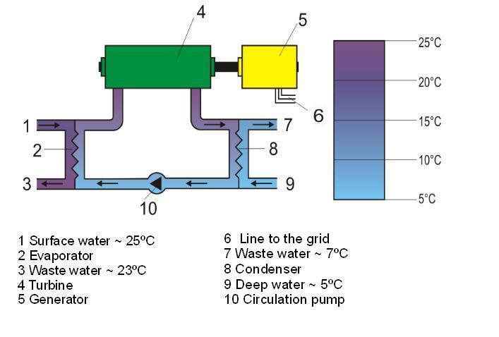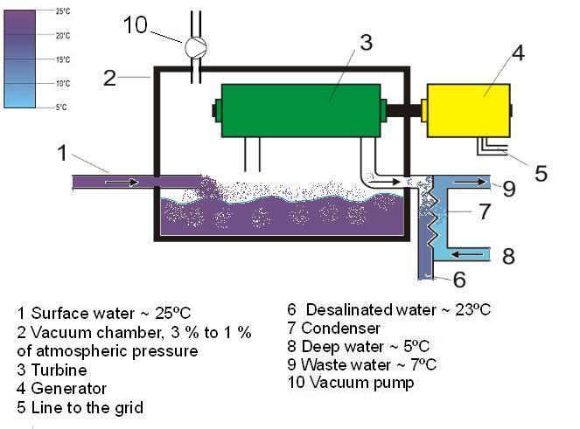

For both processes there ispotential for using the circulating cold water for SWAC, essentially a low-carbon and low-cost replacement for chiller-based cooling. However, in all of these technologies two of the most critical and expensive components are the heat exchangers and the necessary piping. Having both warm and cold water reservoirs near the generation facility and for SWAC, near-demand for cooling, becomes one of the most important criteria for site selection (CAF - Latin America Development Bank, 2015)

The third area of research, usually in conjunction with one of the first two is to analyze the economic feasibility, or at least, the system costs of OTEC, desalination, and accompanying SWAC outputs. Section 5 explores these aspects in more detail, highlighting the main economic considerations where emphasis is placed on the economics of both OC- and CC-OTEC, showing that costs decrease when moving to the CC-OTEC technology due in part to the overall larger size (>10 MW) of these systems compared to smaller OC-OTEC plants (Bernardoni et al., 2019; Devis-Morales, Montoya-Sánchez, Osorio, & Otero-Díaz, 2014; Fujita et al., 2012; Hunt, Byers, & Sánchez, 2019; Vega, 1992, 2010)

1. **Filtering criteria for initial selection**

Nihous (G. C. Nihous, 2007) summarized a rough survey of potential OTEC sites including low-resolution mapping of potential OTEC resources, but looked at sites with temperature difference ~20 °C and within 200 miles of coastlines. However, given the expense of the piping for an OTEC system, only much smaller distances will be practical for onshore OTEC plants. Hunt *et al.* also provided mapping of suitable locations within the region, with an emphasis on SWAC (Hunt et al., 2019) .

Based on previous literature and the straightforward implications due to geometry and technology costs, initial selection criteria for viable OTEC sites will be assessed within the following sections. Here focus is given to the main requirements of having a depth of 1000 m for consistent ~4°C temperature, and that potential OTEC sites be near to coastal areas to minimize piping lengths. For the entire region data were available to for island coastlines defined using the NOAA high resolution shoreline database, and then extended out to a distance of 10 kilometers. The primary bathymetry dataset used was the General Bathymetric Chart of the Oceans[3] which covers the complete extent of the study area at a 15 arc-second resolution. Information on bathymetric source data types is provided with the downloaded grid, with examples including single and multibeam bathymetry, and seismic and sounding surveys. The 10km study area extending from coastlines was further refined with 2.5 km shoreline buffer increments symbolized to emphasize proximity to the coast. Particular areas of interest within the study area were located by identifying the gridded areas of the GEBCO bathymetry dataset at depths greater than 1000 m. Over the extent of the study area the horizontal resolution of the GEBCO 15 arc second depth data was approximately 400 m (range 385-460m).

The Caribbean region is shown in Figure 4. For purposes of organization, we consider two sub-regions. The Greater Antilles consisting of larger islands such as Cuba, Jamaica, Hispaniola (Haiti and the Dominican Republic), and Puerto Rico; the Bahamas and Turks and Caicos Islands are also taken as part of this group. The Lesser Antilles are the islands ranging from the U.S. and British Virgin Islands and Anguilla southward to Trinidad and Tobago, including Barbados and islands near the coast of South America (Aruba, Curaçao, Bonaire and Isla de los Roques). We examine each of these in turn identifying candidate areas within these regions for OTEC implementation based on our chosen criteria. Detailed maps of the bathymetry and distances to the coast for all islands are shown statically in the Supplementary Information online as well as being available as an interactive mapping tool through …(gitlab.com)

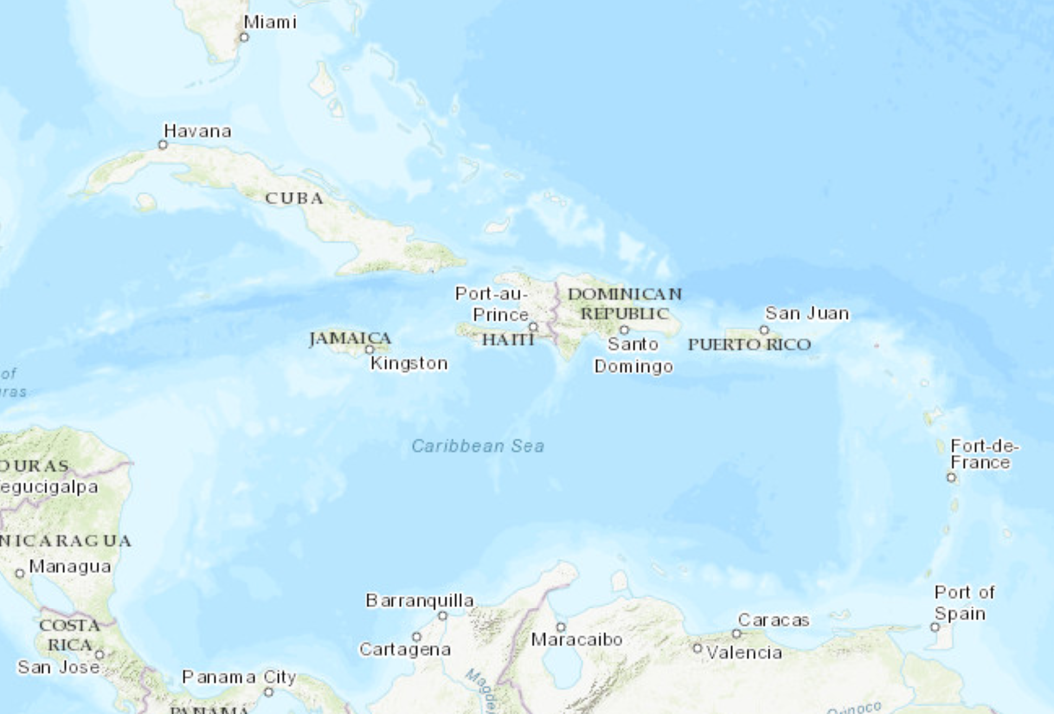

Figure 4 - Map of Caribbean region

**Greater Antilles (with The Bahamas and Turks and Caicos)**

As an example of our analysis we show a map of Jamaica in Fig. 5. On this map, the blue line shows the boundary between regions of <1000m depth and those with depth >1000m. The additional contours are for distances of 2.5km (green), 5.0km (yellow), 7.5km (orange) and 10km (red) from the coast. The interpretation of the map is that any area for which the blue 1000m-depth contour closer to the coast is than a given distance contour will represent cold, deep water at constant temperature. For the sake of evaluation, the most promising locations are those closer than 5km (yellow line) and preferably (in the sense of cost of construction) closer. In the case of Jamaica the best locations from the point of view of near-coastal resource for OTEC would be near Negril, Lucea, southeast of Kingston and near Port Maria and Port Antonio in the northeast. A more detailed list of potential sites in the Greater Antilles is given in Table SI2

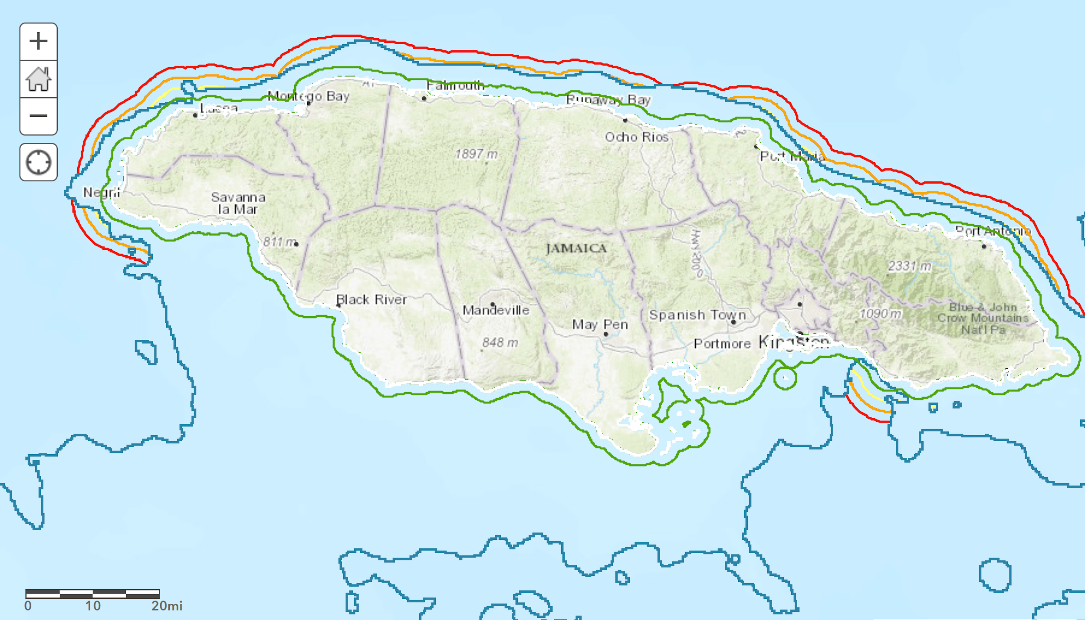

Figure 5 - Map of Jamaica with a bathymetry contour (blue) representing the boundary between depths of greater than and less than 1000m. Other contours are equidistant from the coast at 2.5km (green), 5.0km (yellow), 7.5km (orange) and 10km (red).



**Lesser Antilles**

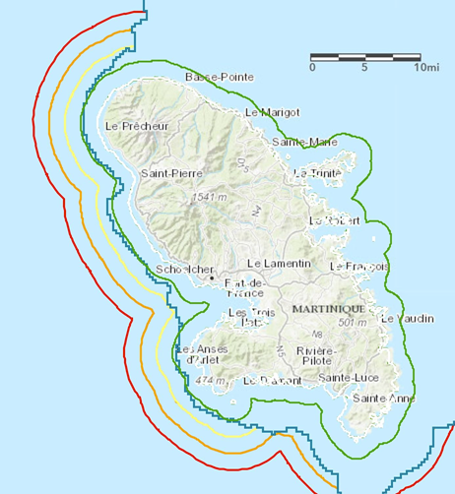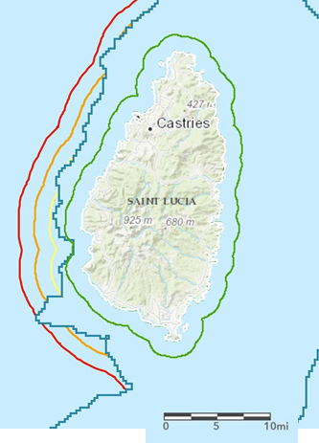. Two examples of islands with promising OTEC locations for the Lesser Antilles are shown in Fig. 6, for Martinique and for Saint Lucia . Several of the Eastern Caribbean islands have deep water within 10 km of the coast.. Again, the area enclosed in red are distances of 10km and distances from the coast of 5km are shown in yellow. Depths of 1000m and greater are outside (*i.e.* farther from the coast) than the blue contour. It can be quickly seen that a number of areas off the coast of islands appear to be viable sites for OTEC, with deep, cold ocean water at distances of 2.5km - 5km or less. A more detailed summary of mapping and potential sites is shown in the SI online, but also includes explicitly those islands with no likely OTEC potential according to these criteria, for example St Kitts and Nevis, Antigua and Barbuda, Aruba and Trinidad and Tobago.

Figure 6 - Fig. 6 - Maps of two example countries in the Lesser Antilles, Martinique and Saint Lucia. Bathymetry contour (blue) represents the boundary between depths of greater than and less than 1000m. Other contours are equidistant from the coast at 2.5km (green), 5.0km (yellow), 7.5km (orange) and 10km (red).

**Summary of promising OTEC sites**

We next further apply a filter to the results obtained thus far and examine potential areas that lie relatively near settled areas, roads or other sites that would be conducive to building and using infrastructure. At this first level of approximation, several islands can fulfill this latter criterion as well. For example, Dominica (near the capital city Roseau), the west coast of Martinique and St. Lucia (near Soufrière) are among the most promising sites, along with several areas in Cuba and Jamaica, amongst others.. Table 2 lists some of the most promising sites.

Table - List of sites with OTEC potential (1000m depth at closer than 5km to the coast) as well as being near towns or other infrastructure

|  |  |  |
| --- | --- | --- |
| Jamaica | Western | Negril (hotels, airport) |
| Jamaica | Northwestern | Lucea |
| Jamaica | Northwestern | Montego Bay |
| Jamaica | Southeast | East of Kingston |
| Grand Cayman | All areas | George Town, Bodden Town, East End, West Bay |
| Cuba | Southeast | Santiago de Cuba |
| Cuba | Northeast | Guardalavaca (tourist resorts) |
| Cuba | Northeast | Playa Uvero, Playa La Playita (tourist resorts) |
| Cuba | Northeast | Havana |
| *Bahamas* | *Central* | *Nassau* |
| *Turks and Caicos Islands* | *East* | *Cockburn Town* |
| *Haiti* | *West* | *Canal de Saint-Marc, Canal de la Gonâve* |
| *Dominican Republic* | *South* | *Barahona, Paraíso, Los Patos* |
| Puerto Rico | Southeast | Guayama |
| *Guadeloupe* | *Northeast* | *Le Moule* |
| *Dominica* | *West coast* | *Roseau, Portsmouth* |
| *Martinique* | *West coast* | *Fort-de-France, St Pierre* |
| *St Lucia* | *Southwest* | *Soufriére* |
| *St Vincent* | *West coast* | *Kingstown* |
|  |  |  |

After this survey of potential OTEC sites, which has not appeared in the literature in this form to-date, to the best of our knowledge, we further reduce the set of potential country candidates to those without large endowments of hydropower or geothermal potential.

The CARICOM nations shown in Fig. 2 can then be analysed based on a 10 MW OTEC integration impact on future energy projections as per the C-SERMS baseline report and assessment. Fig. 7 highlights the projected energy distribution in 2027. A potential OTEC capacity of 10 MW can have the greatest impact in terms of energy generation across the islands with smaller overall power capacity, notably the islands of Dominica, Montserrat and St. Vincent and the Grenadines. Furthermore, islands such as Barbados, Grenada and Jamaica in particular that are aggressively pursuing increased rates of renewable energy penetration can adopt the OTEC technology to supplement the intermittent nature of the dominant renewables of solar and wind. Finally, several islands such as Grenada and Saint Lucia have long included geothermal technology in their energy system planning, but have had challenges in seeing these plans come to fruition; OTEC could be an alternative. These islands and the potential OTEC locations are summarized in Table 2.

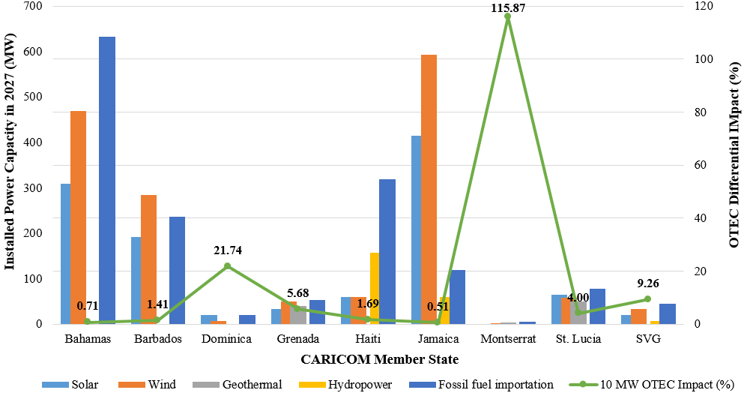

Figure 7 - Relative impact of a 10MW OTEC installed capacity in different countries in CARICOM

1. **Summary of economic parameters for OTEC, desalination and SWAC**

As referenced above, a number of studies have attempted to determine the costs for coupled OTEC and desalination and /SWAC systems. The typical view as been that a) these technologies are not yet ripe, (both technologically and economically), being only in the pilot-project stage, but that b) with enough research and deployment, economies of scale will drive costs down with one of the reasons for examining the feasibility of these coupled systems stems from the hope for better energy economics through the use of these dual-use technologies. However, as shown by the specific cases highlighted here with the filtering of likely areas for OTEC, the feasible sites dwindle in number to a very few.

Starting with the published values in previous research, only a few complete estimates are available. The most complete recent accounting for costs is for a CC-OTEC system (Bernardoni, 2018). A detailed study of both CC and OC systems was carried out by Vega (Vega, 2010). In addition, Kim *et al*. (Kim, *et al.* 2016) provide a detailed technical calculation for a small OC-OTEC system, but with little economic information. In this paper we recognize the large degree of uncertainty in OTEC cost estimates, but bridge the cited literature for our analysis. In the earlier work (Vega, 2010) also assumes an offshore platform for hosting the OTEC system, with the platform, moorings and undersea power cable representing a significant fraction of the total cost, and analyzed a relatively large, generically-placed OTEC plant of 50 MW capacity, having determined that a strong cost advantage arises in moving from plants of 10 MW or less to this larger size. For our proposed application, smaller plants or units on the order of 5 - 10MW capacity are more appropriate; based on estimates by Vega, the specific (i.e. per kW of capacity) capital cost of a 5 MW plant would be approximately three times that of a 50 MW plant. One key point we use for our assumptions, following Vega, is that overall component costs for the CC and OC plants will be approximately equal (Vega, 2010). Using these scaling factors and assumptions, the capital cost for a 5 MW OC-OTEC plant based on Vega would be approximately $13,500/kW (also converting 2009 US$ to 2018 US$ with a producer price index factor of 1.2).

Bernardoni *et al.* analyze a OC-OTEC plant with a net capacity of 2.3MW (after self-consumption is taken into consideration); multiple such units could be combined for a power plant of larger total capacity. Those authors estimate a levelized cost of electricity of €269/MWh (~USD300/MWh or $0.30/kWh) in their base case with a capital cost of €16000/kW (€14000/kW in a low cost case). This result is somewhat higher than that of Vega, but within any reasonable estimate of uncertainty and will be used as a baseline in our analysis, with sensitivity test for lower and higher costs.

As far as production of desalinated water and electricity is concerned, Vega estimates daily production of 118,000m3 and an annual output of electricity (assuming an overall 92% capacity factor) of 414,415 MWh. Kim, *et al.* calculate for operation with 0.5 MW net capacity and 80% capacity factor a fresh water production of 1175m3/day, in very good agreement with Vega. More realistically, especially given the grid integration potential we want to consider here, a capacity factor of ~70% should be taken if sized reasonably for the system, which increases the LCOE. This co-benefit of desalinated water will be considered in our analysis as well. Estimating the cost of water from regional water agencies we take a value of US$2/m3 and test sensitivities for lower and higher water prices.

With these data and parameters as background we now turn to the next set of central considerations and results of this paper.

1. **Load, residual load and system economic benefits of dispatchable capacity**

According to the best available science as summarized by the Intergovernmental Panel on Climate Change (IPCC)) (IPCC SR 1.5, 2019) and to be consistent with the Paris Agreement (Rogelj *et al.*, 2011) requirement of a near-total phase-out of fossil fuels by mid-century, modeling integrated systems of 100% renewable energy has become an increasingly active field of research (Jacobson et al., 2015, Jacobson et al. 2017, Löffler et al., 2017, Ram et al. 2017, Ram et al. 2019). Beyond climate change mitigation, to which SIDS contribute very little due to their small sizes, for many island nations dependence on fossil fuels is a fiscal drain, results in negative externalities in terms of health impacts, and does not contribute to resilience in the face of storm and climate change impacts. The strong decrease in the past decade in the cost of solar photovoltaics, wind power and batteries, and in the near future, of electric vehicles, makes the outlines of a pathway forward to elimination of fossil fuels and reliance on sustainable, renewable sources of energy (International Renewable Energy Agency (IRENA)., 2017; IRENA, 2017, 2018, 2019a, 2020, 2019b; Lazard, 2019a, 2019b) The goal of this section is to examine OTEC, desalination in context.

In general there is a tradeoff between the possibility of integrating high percentages of variable renewables and the use of either storage or a dispatchable power source. As we shall show, adding a relatively small amount of dispatchable capacity, even if expensive (LCOE) when considered in isolation, can enable a significantly increased uptake in much cheaper wind and solar energy. Thus, when one considers an overall *system* LCOE (sLCOE) there can still be a benefit of the apparently expensive technology. (Yang, Bremner, Menictas, & Kay, 2018)

To investigate trade-offs we construct a Python-based model (available at … ) and assume a fictitious Caribbean island with a yearly electricity generation of 250 GWh and a peak demand of 37MW. Hourly demand data can be taken in this case from data available for synthetic demand curves generated as part of 100% renewable energy modeling efforts (Toktarova et al. (2019)); alternatively actual data can be used if these are available. These synthetic load curves tend to all be very similar for smaller Caribbean islands except for the overall amplitude. Comparison with real data also shows a somewhat exaggerated secondary evening peak for the synthetic data.

Solar and wind power generation for a given modeled installed capacity can for a first approximation be obtained from <https://www.renewables.ninja/> based on reanalysis data rather than actual *in situ* measurements. With these data sets, each of which can be scaled in amplitude to represent different levels of production of wind and solar power, as well as for different overall demand, an hourly time series can be constructed that shows the residual load after VRE has been taken into account, *i.e.* load minus solar and wind power. For an assumed installed capacity of a dispatchable source (OTEC in this case, but this could be made up of different sources), if the residual load from VRE is positive, *i.e.* not demand is not satisfied, then the dispatchable source is used to fill in the gap up to its maximum capacity. In the model, the dispatchable source is also assumed to have a minimum output that is chosen to be 25% of the maximum capacity. Finally, storage is integrated into the model with a given capacity (MWh) and power output (MW) (batteries, either at utility-scale or in an integrated grid with electric vehicles, or perhaps hydrogen with fuel cells) such that an oversupply of VRE can charge the storage, or undersupply of VRE + dispatchable source results in discharge of the storage; the dispatchable renewable source can also be used to charge the battery up to its maximum capacity. This process is modeled for each hour of the year with the goal of satisfying demand at each hour, while keeping track as well of the capacity factor of the dispatchable source, the state of charge of the storage, and the total curtailed amount of VRE during the year. A convenient way to visualize the various trade-offs that arise, including that of meeting demand vs. curtailing variable renewable energy (which can in some cases be part of an optimal solution) is through the use of Residual Load Duration Curves.

A variety of combinations of dispatchable renewable source, storage capacity and variable renewable energy (wind + solar pv) can meet demand for all hours of the year. Using this model it is possible to find the amount of storage (in MWh) needed for a given combination of wind, solar pv and dispatchable renewable power (e.g. OTEC) capacities such that demand for all hours of the year is met. Table 5 summarizes input parameters and assumptions used for the scenarios, while Fig. 8 shows results for some potential scenarios the resulting energy mix that leads to coverage of demand for all hours of the year.

Table - Parameters for the evaluation of system levelized costs of energy (sLCOE) for different combinations of solar pv, wind, dispatchable renewable and storage

|  |  |  |
| --- | --- | --- |
| Peak power | 37.2 | MW |
| Yearly energy | 250 | GWh |
| levelized cost of wind | $ 75 | /MWh |
| levelized cost of solar pv | $ 75 | /MWh |
| levelized cost of dispatchable | $ 300 | /MWh |
| levelized cost of storage | $ 300 | /MWh |
| lifetime of storage | 15 | years |
| Lifetime of system | 20 | years |

In Figure 8 two cases are shown in which the dispatchable technology capacity is set at 10MW (Figure 8a) and at 20MW (Figure 8b and the capacities of the variable renewable energy (VRE) technologies are varied from 0 to 200MW. The amount of storage capacity is capped here at 4500 MWh and at 2500 MWh, respectively, for clarity of presentation. The main point to note is the relationship between a decrease in dispatchable power capacity and an increase in necessary storage capacity, becoming more pronounced at lower wind and solar pv capacities. Essentially, for low dispatchable capacity, large amounts of storage are needed, mainly to make up for a relatively small number of extended periods during which wind and solar pv power are both not available. In Figure 8 there is a very sharp rise in battery capacity at low levels of wind and solar capacity; this feature is an artefact of the problem definition and represents the fact that not enough overall capacity is available in the system to cover demand during a significant period of time during the year. 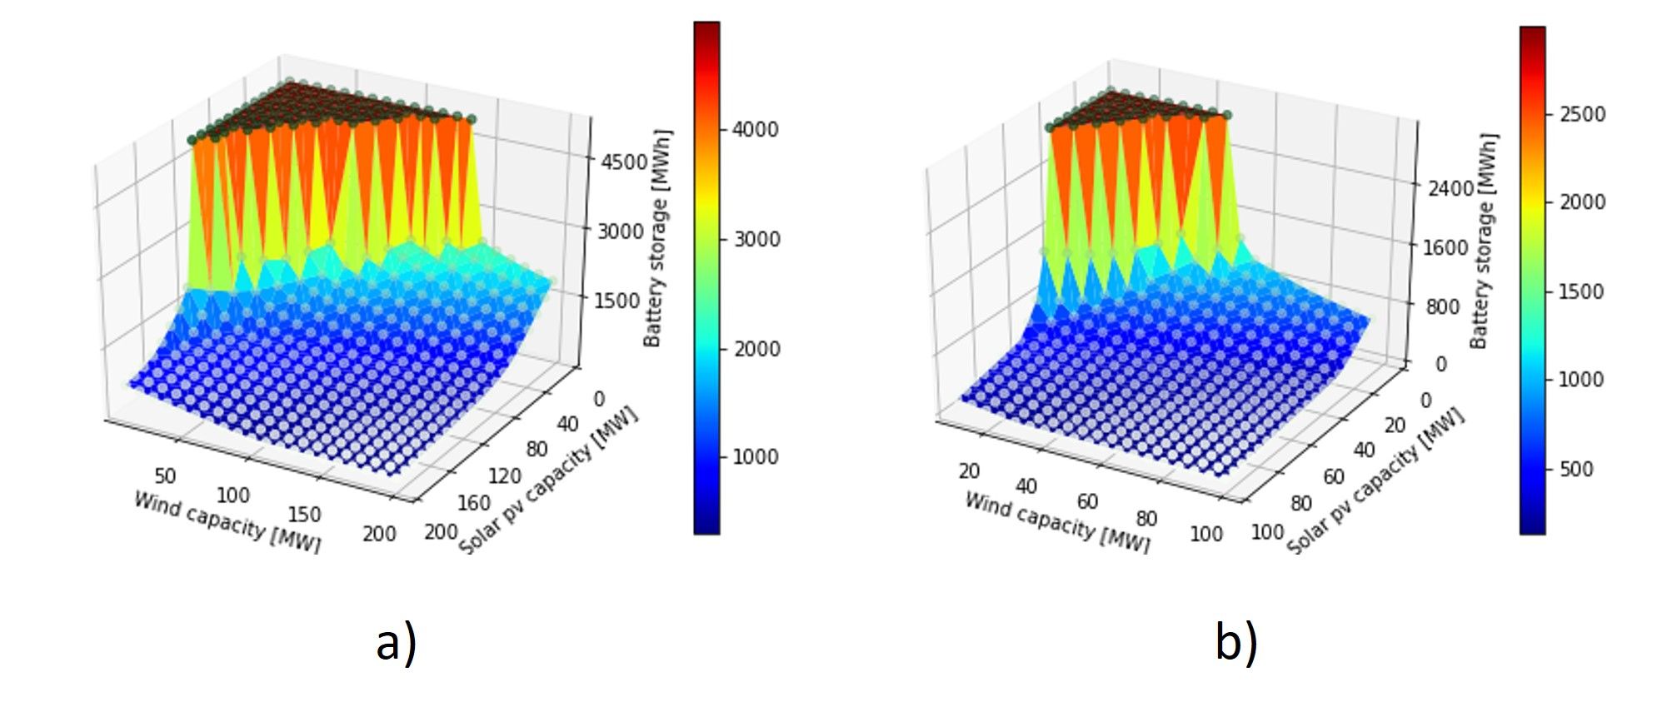

Figure 8 - Necessary amount of storage capacity (in MWh) to allow demand to be satsified for every hour of the year, and as a function of the installed wind and solar pv capacity. a) With 10MW of dispatchable renewable capacity and b) with 20MW of dispatchable renewable capacity. Peak system demand is 37MW in this example.

Table 4 shows results for a selection of cases. Not visible in Figure 8 is the amount of curtailed variable renewable power, which becomes significant as the VRE capacity increases, and thus represents an additional trade-off to be considered. For the selected cases, curtailment is shown; the combination of all these factors contribute to the total system cost. Table 4 also shows the system levelized cost of electricity (sLCOE) for each of the eight cases. In Figure 9a, a further comparison is made for these eight cases, with the blue and orange bars represent the sLCOE both without and with the inclusion of benefits of desalinated water that would be produced by an OC-OTEC system. Also displayed in Fig. 9 is a shaded region that represents estimated LCOE for a diesel reciprocating engine system that has until recently been the power source of choice for many countries.

Table - Sample results for sLCOE (USD/MWh) for different system configurations (solar pv, wind, dispatchable renewable, storage). Comparison is made with and without including the co-benefit of desalination

|  |  |  |  |  |  |  |  |  |  |  |  |
| --- | --- | --- | --- | --- | --- | --- | --- | --- | --- | --- | --- |
| Scenario | Solar [MW] | Solar [GWh] | Wind [MW] | Wind [GWh] | Disp. RE [MW] | Disp. RE [GWh] | Storage capacity [MWh] | Energy from storage [GWh] | Curtail-ment | sLCOE [/MWh] | With desal water contrib. |
| 1 | 200 | 335 | 73 | 204 | 0 | 0 | 2000 | 42.5 | 53% | $ 375 | $ 375 |
| 2 | 140 | 234 | 73 | 204 | 10 | 40 | 1000 | 17.8 | 48% | $ 294 | $ 267 |
| 3 | 120 | 201 | 53 | 150 | 10 | 46 | 1500 | 24.5 | 37% | $ 329 | $ 298 |
| 4 | 100 | 167 | 44 | 122 | 15 | 71 | 1000 | 15.8 | 30% | $ 293 | $ 244 |
| 5 | 90 | 151 | 34 | 95 | 15 | 79 | 1500 | 20.3 | 23% | $ 344 | $ 291 |
| 6 | 80 | 134 | 17 | 48 | 20 | 117 | 1000 | 15.7 | 16% | $ 325 | $ 245 |
| 7 | 90 | 151 | 24 | 68 | 20 | 108 | 500 | 11.3 | 23% | $ 270 | $ 197 |
| 8 | 60 | 100 | 29 | 82 | 25 | 115 | 200 | 2.37 | 16% | $ 237 | $ 159 |

There are several points to note about these summary results. First, costs for solar and wind have been set at $100/MWh; our estimates are conservative in that there are many examples around the world of far lower LCOEs for these technologies, and in fact in more mature markets, power purchase agreements have been tendered with costs of only $30-40/MWh for systems of solar pv or wind energy including battery storage. On the other hand, Caribbean islands have not yet shown the cost decreases to these lowest levels yet. A second point is to emphasize that we use $300/MWh to represent the relatively untested OTEC costs; with other technologies such as geothermal or hydropower the dispatchable source would be expected to have significantly lower LCOE, thus lowering the sLCOE cost with respect to those shown here, even without the added benefit of desalinated water, as illustrated in Figure 9. Even with these caveats and relatively conservative assumptions, the system LCOE for OTEC with the co-benefit of desalinated water, and in some scenarios even without this advantage, is less than it would be for diesel power generation.

To represent some potential and likely future developments, we show in Fig. 9b the same analysis but with an assumed cost of solar pv and wind each of $50/MWh, and storage costs of $150/kWh, keeping the uncertain cost of the dispatchable OTEC source constant at $300/MWh. This situation might represent expected costs by 2030, which is when many Caribbean islands will have increased implementation of variable renewables and will be looking at options for complementing variable renewables with a dispatchable source of renewable energy. It is seen that with these cost decreases, even with the relatively expensive OTEC technology as a backstop, the total system cost of electricity is in nearly all cases less than what would be expected for diesel generators. Taking into account the added benefit of desalinate water the difference is even larger.

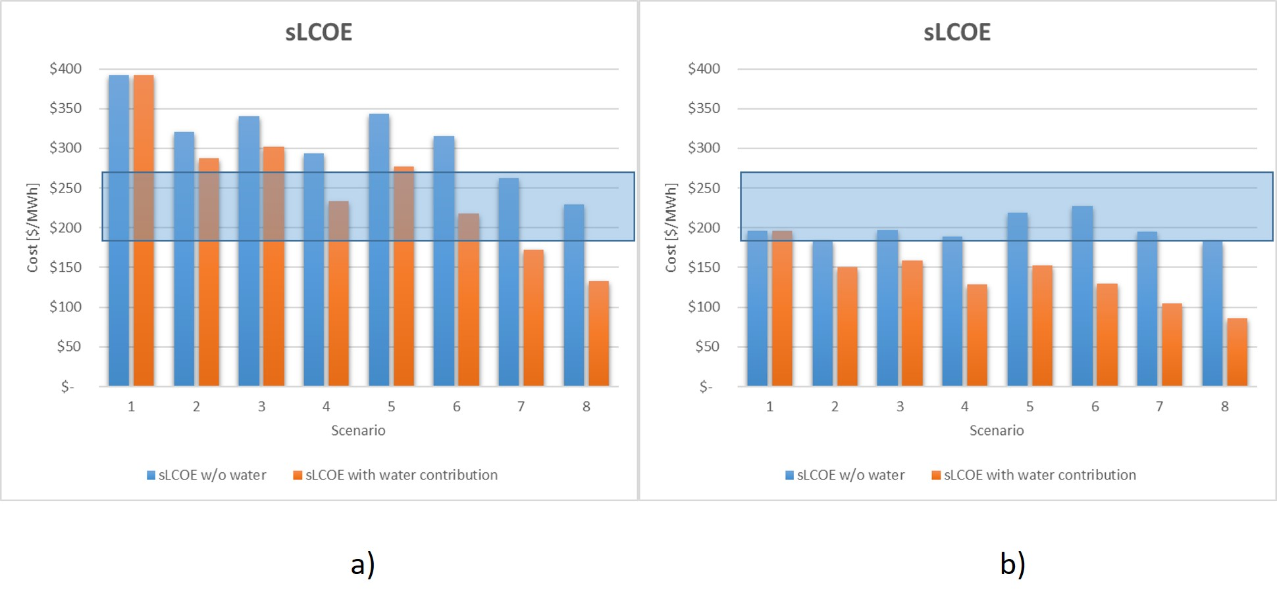

Figure 9 - Comparison of the system levelized cost of electricity (sLCOE) for eight example cases as described in the text and in Table 4. A) with estimated current costs of each technology and b) with estimated costs in 2030, when deep renewable energy penetration will likely be starting to make dispatchable technologies a necessity to complement variable renewable energy sources.

1. **Further considerations for integration**

Sea-based OTEC technologies by their very nature of operation are susceptible to both short- and long-term changes in weather and climate patterns. Their open-water functioning presents many challenges, mostly infrastructural, and Caribbean systems are particularly vulnerable to extremes in weather owing to the pronounced hurricane season and deep convective atmospheric conditions that often result in storm surges and inclement weather during the rainy seasons.

OTEC systems are governed by basic principles of vertical ocean thermal gradients and are relatively simple in their operation, excluding more advanced hybrid and electrolysis complementary operations. Both floating and shelf-based systems involve extensive lengths of piping which can be easily disrupted by turbulent ocean surfaces. Though having these systems at some distance near/offshore provides the advantage of tapping into greater and less variable thermal gradients, they come at a greater infrastructure cost and capital risk. The Caribbean basin is already seeing more weather extremes in recent years and meteorologists have shown through extensive climate models that climate change is making hurricanes more frequent and powerful over the Atlantic Ocean, where they eventually cross the Caribbean Sea via various paths. According to the United Nations, the 2017 hurricane season cost Caribbean countries and the United States USD $92 billion with Irma, María and José leaving islands like Barbuda, Dominica and Puerto Rico completely incapacitated by their passage (The Independent UK, 2018)[4]. Thus, sea-based OTEC systems are considerably more vulnerable to these climatic changes given their operation and offshore siting. The increased variability in the tracks of hurricanes is also adding new challenges for the region when viewed in the light that new countries and economies, once at low-risk to these systems (Guyana and Trinidad and Tobago for instance), may become increasingly vulnerable to these weather extremes.

Climate change is also bringing about unprecedented levels of ocean warming which can play a role in the future of OTEC operations in the Caribbean region. Antuña-Marrero et al. (2015) show that sea surface temperatures (SSTs) within the subperiod 1972–2005 have a warming trend of 1.18 ± 0.49°C per century for the wider Caribbean. Over the wider period of 1906-2005, the authors found a weighted warming trend of 1.32°C per century for the wider Caribbean during the summer period. Although some model discrepancy exists within the early 20th century SST, the wider Caribbean, particularly the southernmost region of the Lesser Antillies, show clear warming trends which threaten to weaken thermal gradients if increased subsurface mixing intensifies as well. However, many sea-based OTEC systems rely on thermal gradients that are achieved by tapping into water well below the surface level. In their study of the island of San Andres off the Colombian coast, Devis-Morales et al. (2014) show that the thermal difference encountered from the surface to a depth of 1000 m, where cooler waters for OTEC can be sourced from, was ~ 22°–24 °C and cold waters are available for intake at around 450–750 m, within a short horizontal distance from the coast (less than 2.5 km).

* new paragraph on weather extremes and growing intensity of hurricanes (add the possibility of mobile OTEC systems that can be harboured; increased CAPEX and OPEX costs involved in maintenance and operation
* discuss the long-term climate implications through changing ocean thermal stratification and the impact on temperature gradients used to drive the system
* end briefly on the OTEC sector drawing technological and industry insights from the oil sector to better aid into the transition to SIDS economies

For discussion on homogenous ocean warming:

1. **Conclusions**

We have presented a set of observations about achieving the challenging goal of 100% renewable energy systems Caribbean Island States. By their very nature these countries and territories have limitations in both resources and interconnections that would otherwise ease the transition to fossil-free energy systems. In Europe or the United States, for example, large areas with solar, wind, hydroelectric, biomass and other potential energy sources are connected by regional electricity grids operating within a mature marketplace of energy suppliers and distributors. Despite these enhanced grids and energy sectors, the transition to renewables is certainly not always streamlined in more economically developed countries. Small Island Developing States (SIDS), including those in the Caribbean have, however, committed to fulfilling ratified obligations outlined in the Paris Agreement. In the Caribbean, the 1.5°C (rise) temperature target has been adopted as a necessary threshold for the region {cite}, given the dire threats from sea-level rise, temperature changes, and tropical cyclones that are already increasing measurably and will do so even more in a world beyond 1.5°C {cite}. One of the key findings of the IPCC Special Report on Global Warming of 1.5°C (Intergovernmental Panel on Climate Change (IPCC)., 2018) is that the world needs to be carbon-emission neutral by mid-century. If this is taken as a guiding concept, roughly thirty years remain for all countries to decarbonize their energy systems. A seemingly insurmountable task for many less economically developed countries.

The positive side of this scenario of transformation is that Caribbean Islands are wealthy in the inexhaustible natural resources of solar and wind power. Furthermore, there has been a dramatic reduction in the cost of wind turbines and solar PV panels over the past decade, bringing the cost of these technologies to a level competitive with the existing fossil-fuel generation used by most Caribbean islands. There remains the question of up-front capital costs, which would be relevant one way or another as fossil-fuel generation capacity must be phased out with increasing pressure in the coming decade . As we have shown, there are various options on different islands for complementing the wealth of solar and wind potential with other technologies. These are however limited to some extent by geography, geology and topology, but even in countries without these resources, battery storage has become increasingly viable although the CAPEX of many of these technologies are not the least expensive option for a power system, limiting their deployment in the Caribbean region.

There are clearly challenges to rebuilding energy systems, whether in the Caribbean or elsewhere. Islands in tropical regions offer both large hurdles, but also significant advantages and the opportunity to serve as models for how to diverge from a business-as-usual path of fossil-fuel dependence and move toward a sustainable, renewable energy future.

Acknowledgements: RJB is funded by EU Horizon2020 Marie-Curie Fellowship Program

(H2020-MSCA-IF-2018, proposal number 838667 – INTERACTION)

Author contributions: RJB conceptualized the research and developed the hourly demand and supply model. KS did the GIS mapping. MA and RKK provided regional expertise and input to the framing of the manuscript. RJB drafted the manuscript, RJB, MA and RKK edited and revised the manuscript.

Arena, U., Ardolino, F., & Di Gregorio, F. (2015). A life cycle assessment of environmental performances of two combustion- and gasification-based waste-to-energy technologies. *Waste Management*, *41*, 60–74. https://doi.org/10.1016/j.wasman.2015.03.041

Arrow, K. J. (1962). The Economic Implications of Learning by Doing. *The Review of Economic Studies*, *29*(3), 155. https://doi.org/10.2307/2295952

Bernardoni, C., Binotti, M., & Giostri, A. (2019). Techno-economic analysis of closed OTEC cycles for power generation. *Renewable Energy*, *132*, 1018–1033. https://doi.org/10.1016/j.renene.2018.08.007

CAF - Latin America Development Bank. (2015). *A Pre-Feasibility Study for Deep Seawater Air Conditioning Systems in the Caribbean*. (October), 76. Retrieved from http://scioteca.caf.com/bitstream/handle/123456789/806/Caribbean_SWAC_Final_Report_01-10.pdf?sequence=5&isAllowed=y

Chen, A. A., Stephens, A. J., Koon, R. K., Ashtine, M., & Koon, K. M. (2020). Pathways to climate change mitigation and stable energy by 100 % renewable for a small island : Jamaica as an example. *Renewable and Sustainable Energy Reviews*, *121*(March 2019), 109671. https://doi.org/10.1016/j.rser.2019.109671

Creutzig, F., Agoston, P., Goldschmidt, J. C., Luderer, G., Nemet, G., & Pietzcker, R. C. (2017). The underestimated potential of solar energy to mitigate climate change. *Nature Energy*, *2*. https://doi.org/doi:10.1038/nenergy.2017.140

Devis-Morales, A., Montoya-Sánchez, R. A., Osorio, A. F., & Otero-Díaz, L. J. (2014). Ocean thermal energy resources in Colombia. *Renewable Energy*, *66*(2014), 759–769. https://doi.org/10.1016/j.renene.2014.01.010

Fujita, R., Markham, A. C., Diaz Diaz, J. E., Rosa Martinez Garcia, J., Scarborough, C., Greenfield, P., … Aguilera, S. E. (2012). Revisiting ocean thermal energy conversion. *Marine Policy*, *36*(2), 463–465. https://doi.org/10.1016/j.marpol.2011.05.008

Grübler, A., Nakićenović, N., & Victor, D. G. (1999). Dynamics of energy technologies and global change. *Energy Policy*, *27*(5), 247–280. https://doi.org/10.1016/S0301-4215(98)00067-6

Hunt, J. D., Byers, E., & Sánchez, A. S. (2019). Technical potential and cost estimates for seawater air conditioning. *Energy*, *166*, 979–988. https://doi.org/10.1016/j.energy.2018.10.146

Ikegami, Y., Yasunaga, T., & Morisaki, T. (2018). Ocean Thermal Energy Conversion using double-stage Rankine Cycle. *Journal of Marine Science and Engineering*, *6*(1). https://doi.org/10.3390/jmse6010021

Intergovernmental Panel on Climate Change (IPCC). (2018). *Global Warming of 1.5°C. An IPCC Special Report on the impacts of global warming of 1.5°C above pre-industrial levels and related global greenhouse gas emission pathways* (T. W. Masson-Delmotte, V., P. Zhai, H.-O. Pörtner, D. Roberts, J. Skea, P.R. Shukla, A. Pirani, W. Moufouma-Okia, C. Péan, R. Pidcock, S. Connors, J.B.R. Matthews, Y. Chen, X. Zhou, M.I. Gomis, E. Lonnoy, T. Maycock, M. Tignor, ed.). Retrieved from https://www.ipcc.ch/site/assets/uploads/sites/2/2019/02/SR15_Chapter2_Low_Res.pdf

International Renewable Energy Agency (IRENA). (2017). *Electric Vehicles: Technology Brief*.

IRENA. (2017). Electricity storage and renewables: Costs and markets to 2030. In *Electricity-storage-and-renewables-costs-and-markets*. https://doi.org/ISBN 978-92-9260-038-9 (PDF)

IRENA. (2018). *Renewable Power Generation Costs in 2017*. Retrieved from www.irena.org

IRENA. (2019a). *TOWARDS 100% RENEWABLE ENERGY: STATUS, TRENDS AND LESSONS LEARNED*.

IRENA. (2020). *Renewable Power Generation Costs in 2019*.

IRENA (International Renewable Energy Agency). (2014). *Ocean Energy - Technology Readiness, Patent, Deployment Status and Outlook*.

IRENA, (International Renewable Energy Agency). (2019b). *Renewable-Powered Future : Solutions To Integrate*.

Kim, A. S., Kim, H. J., Lee, H. S., & Cha, S. (2016a). Dual-use open cycle ocean thermal energy conversion (OC-OTEC) using multiple condensers for adjustable power generation and seawater desalination. *Renewable Energy*, *85*, 344–358. https://doi.org/10.1016/j.renene.2015.06.014

Kim, A. S., Kim, H., Lee, H., & Cha, S. (2016b). Dual-use open cycle ocean thermal energy conversion ( OC-OTEC ) using multiple condensers for adjustable power generation and seawater desalination. *Renewable Energy*, *85*, 344–358. https://doi.org/10.1016/j.renene.2015.06.014

Koon Koon, R., Marshall, S., Morna, D., McCallum, R., & Ashtine, M. (2020). A Review of Caribbean Geothermal Energy Resource Potential. *The West Indian Journal of Engineering*, *42*(2), 37–43. Retrieved from http://sta.uwi.edu/eng/wije/documents/WIJE_v42n2_Jan2020.pdf

Lazard. (2019a). *Lazard’s levelized cost of energy analysis — version 13.0*. Retrieved from https://www.lazard.com/media/451086/lazards-levelized-cost-of-energy-version-130-vf.pdf

Lazard. (2019b). *LAZARD’S LEVELIZED COST OF STORAGE ANALYSIS—VERSION 5.0*. Retrieved from https://www.lazard.com/media/451087/lazards-levelized-cost-of-storage-version-50-vf.pdf

Lennard, D. E. (1995). The viability and best locations for ocean thermal energy conversion systems around the world. *Renewable Energy*, *6*(3), 359–365.

Lewis, A., Estefen, S., Huckerby, J., Musial, W., Pontes, T., & Torres-Martinez, J. (2011). Ocean Energy. In *IPCC Special Report on Renewable Energy Sources and Climate Change Mitigation*.

Mutair, S., & Ikegami, Y. (2014). Design optimization of shore-based low temperature thermal desalination system utilizing the ocean thermal energy. *Journal of Solar Energy Engineering, Transactions of the ASME*, *136*(4), 1–8. https://doi.org/10.1115/1.4027575

Nemet, G. F. (2006). Beyond the learning curve: factors influencing cost reductions in photovoltaics. *Energy Policy*, *34*(17), 3218–3232. https://doi.org/10.1016/j.enpol.2005.06.020

Nihous, G. C. (2007). A preliminary assessment of ocean thermal energy conversion resources. *Journal of Energy Resources Technology, Transactions of the ASME*, *129*(1), 10–17. https://doi.org/10.1115/1.2424965

Nihous, Ǵrard C. (2010). Mapping available Ocean Thermal Energy Conversion resources around the main Hawaiian Islands with state-of-the-art tools. *Journal of Renewable and Sustainable Energy*, *2*(4), 2–11. https://doi.org/10.1063/1.3463051

Ochs, A. et al. (2015). *Caribbean Sustainable Energy Roadmap and Strategy*. Washington D.C., USA.

Park, S., Chun, W., & Kim, N. (2017). Simulated production of electric power and desalination using Solar-OTEC hybrid system. *International Journal of Energy Research*, *41*(5), 637–649. https://doi.org/10.1002/er.3641

Tello Espinoza, P., Arce, E. M., Daza, D., Soulier Faure, M., & Terraza, H. (2010). *REGIONAL EVALUATION ON URBAN SOLID WASTE MANAGEMENT IN LATIN AMERICA AND THE CARIBBEAN - 2010 REPORT*.

Vega, L. A. (1992). Economics of ocean thermal energy conversion (OTEC). *Ocean Energy Recovery - The State of the Art*, 152–181.

Vega, L. A. (2010). Economies of ocean thermal energy conversion (OTEC): An update. *Proceedings of the Annual Offshore Technology Conference*, *4*, 3239–3256. https://doi.org/10.4043/21016-ms

Wang, M., Jing, R., Zhang, H., Meng, C., Li, N., & Zhao, Y. (2018). An innovative Organic Rankine Cycle (ORC) based Ocean Thermal Energy Conversion (OTEC) system with performance simulation and multi-objective optimization. *Applied Thermal Engineering*, *145*(August), 743–754. https://doi.org/10.1016/j.applthermaleng.2018.09.075

Watt, A. D., Mathews, F. S., & Hathaway, R. E. (1977). *OPEN CYCLE OCEAN THERMAL ENERGY CONVERSION. A PRELIMINARY ENGINEERING EVALUATION*.

Yekini Suberu, M., Wazir Mustafa, M., & Bashir, N. (2014). Energy storage systems for renewable energy power sector integration and mitigation of intermittency. *Renewable and Sustainable Energy Reviews*, *35*, 499–514. https://doi.org/10.1016/j.rser.2014.04.009

Antuña‐Marrero, J. C., Otterå, O. H., Robock, A., & Mesquita, M. D. S. (2016). Modelled and observed sea surface temperature trends for the Caribbean and Antilles. International Journal of Climatology, 36(4), 1873-1886.

Cole, Wesley and A. Will Frazier (2019) Cost Projections for Utility-Scale Battery Storage. Golden, CO: National Renewable Energy Laboratory. NREL/TP-6A20-73222. https://www.nrel.gov/docs/fy19osti/73222.pdf.

GEBCO (2020) **Ge**neral **B**athymetric **C**hart of the **O**ceans <https://www.gebco.net/>, last accessed Aug. 24, 2020

The Independent UK. (2018). Hurricanes Harvey, Irma and Maria pushed natural catastrophe insurance costs to a record high last year, study shows. Retrieved from https://www.independent.co.uk/news/business/news/hurricane-harvey-irma-maria-insurance- cost-natural-catastrophes-record-high-2017-a8297696.html. Accessed on August 12, 2020.

.

IPCC SR 1.5. (2019). *IPCC Special Report on 1.5: Global warming of 1.5C* (Vol. 85).

Jacobson, M.Z. et al. (2015). 100% clean and renewable wind, water and sunlight (WWS) all-sector energy roadmaps for the 50 United States. *Energy and Environmental Science*, **8**, 2093-2117 DOI: 10.1039/c5ee01283j

Jacobson, M.Z. et al. (2017). 100% Clean and renewable wind, water, and sunlight all-sector energy roadmaps for 139 countries of the world. *Joule* **1**, 108-121 http://dx.doi.org/10.1016/j.joule.2017.07.005

Lewis, A., Estefen, S., Huckerby, J., Musial, W., Pontes, T., & Torres-Martinez, J. (2011). Ocean Energy. In *IPCC Special Report on Renewable Energy Sources and Climate Change Mitigation*.

Löffler, K. et al (2017). Designing a Model for the Global Energy System—GENeSYS-MOD: An Application of the Open-Source Energy Modeling System (OSeMOSYS). *Energies* **10**, 1468 doi:10.3390/en10101468

Ram, M. et al. (2017) Global Energy System based on 100% Renewable Energy - Power Sector, Study by Lappeenranta University of Technology and Energy Watch Group

Ram, M. et al. (2019) Global Energy System based on 100% Renewable Energy - Power, Heat, Transport and Desalination sectors. Study by Lappeenranta University of Technology and Energy Watch Group

Reuters. (2018). Hurricane forecasters see above-average 2018 U.S. storm season. Retrieved from https://www.reuters.com/article/us-weather-hurricanes-forecasts/hurricane-forecasters-see-above-average-2018-u-s-storm-season- idUSKCN1HC2CB. Accessed on August 12, 2020.

Rogelj, J., Hare, W., Lowe, J., van Vuuren, D. P., Riahi, K., Matthews, B., … Meinshausen, M. (2011). Emission pathways consistent with a 2 °C global temperature limit. *Nature Climate Change*, *1*(8), 413–418. https://doi.org/10.1038/nclimate1258

Teske, S. (ed.) (2019). Achieving the Paris Climate Agreement Goals: Global and Regional 100% Renewable Energy Scenarios with Non-energy GHG Pathways for +1.5C and +2C (Springer, Switzerland) https://doi.org/10.1007/978-3-030-05843-2

Toktarova, A. et al. (2019) Long term load projection in high resolution for all countries globally *Electrical Power and Energy Systems* **111**  160–181 https://doi.org/10.1016/j.ijepes.2019.03.055

Yeh, R. H., Su, T. Z., & Yang, M. S. (2005). Maximum output of an OTEC power plant. *Ocean Engineering*, *32*(5–6), 685–700. https://doi.org/10.1016/j.oceaneng.2004.08.011

1. https://gain.nd.edu/
2. https://en.wikipedia.org/wiki/Ocean_thermal_energy_conversion
3. https://www.gebco.net/
4. https://www.independent.co.uk/news/business/news/hurricane-harvey-irma-maria-insurance- cost-natural-catastrophes-record-high-2017-a8297696.html